Enhancing Algorithmic Trading Strategies with Machine Learning: A Python-based Approach (November 2023)

HT Nkuna

Department of Computer Systems Engineering

Faculty of ICT

Tshwane University of Technology

Pretoria, South Africa

[214755718@tut4life.ac.za /](mailto:214755718@tut4life.ac.za%20/) trevornkuna7@gmail.com

**Abstract - In this study, we explore the fusion of machine learning and technical analysis in algorithmic trading, with a specific focus on the dynamic cryptocurrency markets. Employing Python for its robustness, we engage with data sourced from the Alpaca API to integrate Long Short-Term Memory (LSTM) networks for predictive market analysis. Our system undergoes rigorous evaluation through extensive backtesting, assessing its capabilities against traditional trading methods. This paper reveals the significant advantages of merging advanced machine learning techniques with detailed technical analysis. We demonstrate a novel approach for effectively navigating the complexities of cryptocurrency trading, suggesting a promising direction for future trading strategies. Our findings present a compelling case for the utilization of these sophisticated tools in enhancing market predictions and trading efficiency. This exploration not only contributes to the current body of knowledge but also opens avenues for further research, particularly in refining these models for enhanced accuracy and reliability in market forecasting.**

**Keywords: Algorithmic Trading, Machine Learning, Python, Cryptocurrency, Technical Analysis, LSTM, Alpaca API.**

I. Introduction

The ever-evolving landscape of financial markets has witnessed a paradigm shift with the advent of algorithmic trading, which employs computer programs to execute trades at high speeds and volumes, based on predetermined criteria. This paper aims to contribute to this field by integrating machine learning models with technical analysis to develop an advanced trading system. The focus is primarily on cryptocurrency markets, known for their volatility and dynamic nature. This study aims to leverage Python, a powerful programming language, to build and evaluate an algorithmic trading system that synthesizes data from the Alpaca API with LSTM networks for predictive analysis.

*A. Background and Motivation*

The financial market, a complex adaptive system, is influenced by a myriad of factors, including economic indicators, political events, and market sentiment. Traditional trading strategies, while effective to a degree, often fall short in capturing the nuances of market dynamics. The advent of machine learning offers a new frontier in financial analysis, providing tools to decipher complex patterns and make informed decisions in real-time. This study is motivated by the potential of machine learning to enhance trading strategies, particularly in the unpredictable cryptocurrency market.

*B. Objective and Scope of the Paper*

Our primary objective is to construct a Python-based algorithmic trading system that amalgamates technical analysis and machine learning. We aim to apply this system to the cryptocurrency market, using historical price and volume data to evaluate its performance. This paper intends to provide a comprehensive overview of the system's development process, including data acquisition, preprocessing, model implementation, and performance evaluation.

II. Literature Review

This Literature Review provides a consolidated overview of the key scholarly materials and findings that underpin the development of the algorithmic trading system described in this study. It delves into the historical progression of algorithmic trading, the pivotal role of machine learning in financial markets, the application of technical analysis, and the emergence of Python as a leading tool in financial analysis.

1. *Evolution of Algorithmic Trading*

Algorithmic trading has seen a significant transformation from the days of open outcry to the modern electronic systems that dominate today's financial markets. The literature tracks the expansion of algorithmic trading from basic market-making to complex multi-asset strategies, emphasizing the growing importance of speed and data analysis. Key works outline the progression from manual to automated trading, highlighting the role of computational algorithms in exploiting market inefficiencies.

1. *Machine Learning in Financial Markets*

Recent studies have brought to light the profound impact of machine learning on financial markets. Machine learning algorithms have been lauded for their ability to digest vast amounts of data and identify non-linear patterns, providing a competitive edge in market prediction and trading strategy optimization. The literature also discusses the challenges of overfitting and the need for robust validation techniques, which are paramount considerations in our methodology.

1. *Technical Analysis in Trading Strategies*

The incorporation of technical analysis into algorithmic trading is a well-established practice, as evidenced by the literature. Historical market data, such as price and volume, form the basis for indicators and models that aim to forecast future market behavior. The literature underlines the effectiveness of combining technical analysis with machine learning models to enhance predictive accuracy and the generation of trading signals.

1. *Python as a Tool for Financial Analysis*

Python's ascendancy as a tool for financial analysis is well documented in the literature. Its accessibility, combined with a rich ecosystem of libraries such as pandas, NumPy, and scikit-learn, facilitates data handling, model development, and computational analysis. Python's integration capabilities with other programming languages and tools align with the literature's emphasis on the need for a flexible and powerful programming environment in financial analysis.

III. Methodology

This section articulates the methodology adopted for developing and comparatively analyzing two predictive models: Long Short-Term Memory (LSTM) networks and Gradient Boosting (GB) models. The methodology encompasses data acquisition, preprocessing, model development, and evaluation.

*A. Data Acquisition and Preprocessing*

The foundation of our algorithmic trading system is robust and reliable market data acquired from the Alpaca API, which provides real-time access. During preprocessing, we clean and normalize the data to ensure its suitability for analysis. This involves:

* Handling missing values by applying imputation techniques or discarding incomplete records.
* Normalizing price scales to a common range or standard deviation.
* Aligning time series data across different markets to ensure synchronous inputs for model training.

Pseudocode for Data Preprocessing:

def preprocess_data(data):

# Handle missing values

data.fillna(method='ffill', inplace=True)

# Normalize price scales

data['price'] = (data['price'] - data['price'].mean()) / data['price'].std()

# Align time series data

data = data.asfreq('min', method='pad')

return data

*B. Technical Analysis*

Technical analysis is a key component of our strategy, employing indicators such as MACD and RSI computed using the pandas_ta library. These indicators are essential for understanding market trends and momentum.

Mathematical Model for Technical Indicators:

MACD = ${EMA}_{12}\left(price\right)- {EMA}_{26}(price)$

RSI = $100-\frac{100}{1+RS}$, where RS = $\frac{Average gain}{Average loss}$

Pseudocode:

# Calculate Exponential Moving Average (EMA)

def calculate_EMA(prices, period):

ema= prices.ewm(span=period, adjust=False).mean()

return ema

# Calculate Moving Average Convergence Divergence (MACD)

def calculate_MACD(prices):

ema_12 = calculate_EMA(prices, 12)

ema_26 = calculate_EMA(prices, 26)

macd = ema_12 - ema_26

signal = calculate_EMA(macd, 9)

return macd, signal

# Calculate Relative Strength Index (RSI)

def calculate_RSI(prices, period=14):

delta = prices.diff()

gains, losses = delta.copy(), delta.copy()

gains[gains < 0] = 0

losses[losses > 0] = 0

avg_gain = gains.rolling(window=period).mean()

avg_loss = losses.abs().rolling(window=period).mean()

rs = avg_gain / avg_loss

rsi = 100 - (100 / (1 + rs))

return rsi

*C. Perdictive Model Implementation*

*1. Long Short-Term Memory (LSTM) Networks*

We utilize an LSTM network for its ability to learn long-term dependencies, which is crucial in the volatile cryptocurrency market.

Mathematical Model for LSTM Networks:

Forget gate : $f_{t}$ = ơ( $W_{f}$. [$h_{t}-1, x_{t}$] + $b_{f}$)

Input gate : $i_{t}$ = ơ( $W_{i}$. [$h_{t}-1, x_{t}$] + $b_{i}$)

Cell state update:

$C_{t}$ = $f_{t}$ $C_{t}-1$*+ $i_{t}$ $tanh⁡(W_{c}$* . [$h_{t}-1, x_{t}$] + $b_{c} )$

Output gate : $o_{t}$ = ơ( $W_{o}$. [$h_{t}-1, x_{t}$] + $b_{o}$)

Hidden state: $h_{t}$ = $o_{t}*\tanh{(C_{t})}$

The LSTM unit includes a set of gates that regulate information flow, described by the following equations:

Pseudocode for LSTM model:

# LSTM network implementation

def lstm_forward_pass(inputs, weights, biases):

# Initialize states

h_prev, C_prev = np.zeros_like(weights['Wo']), np.zeros_like(weights['Wo'])

for x in inputs:

f = sigmoid(np.dot(weights['Wf'], np.hstack([h_prev, x])) + biases['bf'])

i = sigmoid(np.dot(weights['Wi'], np.hstack([h_prev, x])) + biases['bi'])

C_bar = np.tanh(np.dot(weights['WC'], np.hstack([h_prev, x])) + biases['bC'])

C = f * C_prev + i * C_bar

o = sigmoid(np.dot(weights['Wo'], np.hstack([h_prev, x])) + biases['bo'])

h = o * np.tanh(C)

h_prev, C_prev = h, C

return h

*2. Gradient Boosting (GB) Models*

GB models are robust ensemble learners that iteratively correct previous predictions, well-suited for non-linear patterns typical in financial data.

Mathematical Model for GB:

Gradient Boosting constructs a strong learner *F*(*x*) as an ensemble of weak learners (trees):

$F\left(x\right)= \sum_{m=1}^{M}{ƴm hm (x)}$, where $hm \left(x\right)is the m-th tree and$ $ƴm$ is the contribution to the overall model.

Pseudocode for Gradient Boost:

def gradient_boosting(X, y, M, learning_rate):

# Initialize model

F = np.mean(y)

*D. System Architecture*

The system architecture integrates various components, including data acquisition, preprocessing, technical analysis, and machine learning models. It is designed to be modular, allowing for the seamless integration of additional data sources and analytical models in the future. The architecture is also scalable, capable of handling large datasets and complex computations required for real-time trading.

IV. Results and Discussion

This section will elaborate on the findings from the application of the developed algorithmic trading system, which includes data processing, model training, backtesting, and forward testing strategies.

* Data Range Used:
* LSTM and Gradient Boosting (GB) Model Training Data: January 1, 2023, to October 6, 2023.
* Forward Testing Data: November 27, 2023, to November 30, 2023.
* Features Used:
* Technical and sentiment analysis indicators: Open, High, Low, Close, Volume, Trade Count, VWAP, MACD, RSI, Turbulence, ATR, OBV, Anomaly.
* The models were trained on historical minute-level granularity data for Bitcoin (BTC/USD) and Ethereum (ETH/USD).

*A. Data Representation*

We initiated our study by obtaining a dataset of financial assets using the Alpaca API. The dataset comprised various attributes, including class, exchange, symbol, status, and trade eligibility (See Figure 1). This dataset was then filtered to retain only active and tradable assets, which were fed into the subsequent analytical processes.

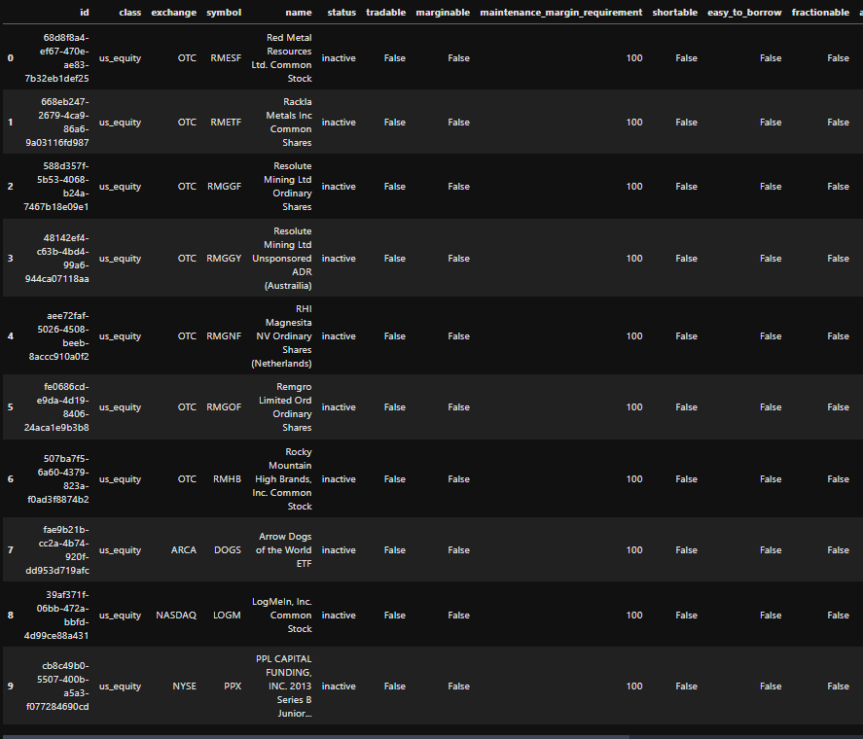

Figure 1: Data table showing financial assets and their attributes obtained from the Alpaca API.

*B. Market Data Analysis*

The system further processed high-frequency trading data for cryptocurrencies, specifically Bitcoin and Ethereum. The retrieved data included minute-level granularity of open, high, low, close prices, volume, trade count, and VWAP (See Figure 2). This granular data is the backbone of our technical analysis and predictive modeling.

Figure 2: Time-series plot of cryptocurrency prices, demonstrating data granularity and market fluctuations.

*C. Sentiment Analysis*

An innovative aspect of our approach included sentiment analysis, where we processed news headlines to assign sentiment scores. This was complemented by anomaly detection using an Isolation Forest algorithm to identify outliers in sentiment data, which might indicate significant market-moving events (See Figure 3).

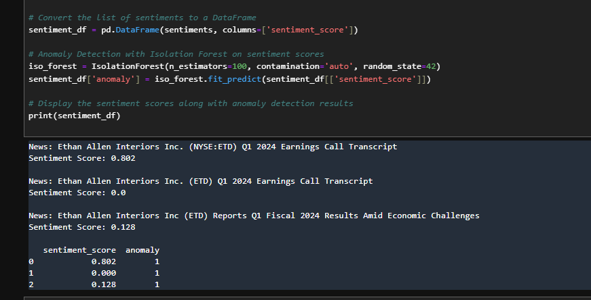

Figure 3: Bar chart displaying sentiment scores from news headlines and the results of anomaly detection.

Sentiment analysis often relies on a model that assigns a numerical value to a piece of text, indicating whether the sentiment is positive, negative, or neutral. Here's a simplified mathematical model for sentiment analysis:

Mathematical Model:

Let *V* be a piece of text to be analyzed. The text *V* is tokenized into words or phrases {*w*1​,*w*2​,...,*wn*​}. Each token *wi*​ has an associated sentiment score *S*(*wi*​), which can be looked up in a precompiled sentiment lexicon or learned from training data.

The overall sentiment score *S*(*V*) for the text *V* is computed as a combination of the sentiment scores of individual tokens:

$$S\left(V\right)=\frac{1}{n}\sum_{i=1}^{n}{S(w_{i})}$$

If *S*(*V*)>0, the sentiment is positive; if *S*(*V*)<0, the sentiment is negative; and if *S*(*V*)=0, the sentiment is neutral.

Pseudocode:

import nltk

from nltk.sentiment import SentimentIntensityAnalyzer

nltk.download('vader_lexicon')

# Initialize the VADER sentiment intensity analyzer

sia = SentimentIntensityAnalyzer()

def analyze_sentiment(text):

# Obtain polarity scores for the text

sentiment_dict = sia.polarity_scores(text)

# Decide sentiment as positive, negative and neutral

if sentiment_dict['compound'] >= 0.05:

return "Positive"

elif sentiment_dict['compound'] <= -0.05:

return "Negative"

else:

return "Neutral"

# Example usage:

text = "I love sunny days."

print(f"Sentiment: {analyze_sentiment(text)}")

# It will output: Sentiment: Positive

1. *Anomaly detection*

The Isolation Forest algorithm, a method used for anomaly detection in your financial data, is deeply mathematical and complex. This algorithm essentially isolates anomalies instead of profiling normal data points. The process is as follows:

Creation of Isolation Trees (iTrees): The dataset is recursively partitioned by randomly selecting a feature and then randomly selecting a split value between the maximum and minimum values of the selected feature. This results in iTrees, where anomalies are those instances that have shorter paths in these trees.

Anomaly Scoring: Once the iTrees are created, the path length to isolate a point is used to calculate an anomaly score. Anomalies are expected to have shorter path lengths in the iTrees.

Ensemble Approach: Multiple iTrees are created to form an Isolation Forest. The average path length over all trees is used to determine the normality or anomaly of a point. Shorter paths suggest anomalies.

Mathematical Model: The probability structure of the isolation random forest is defined, and mathematical proofs are presented to establish the reliability of the method. The key concept is that anomalies are 'few and different,' which makes them more susceptible to isolation.

Convergence and Cardinality: The algorithm is shown to converge, and the cardinality of the isolation random forest (the number of distinct trees) is computed.

The mathematical model for the Isolation Forest algorithm focuses on the probability and expected path length of isolating observations in a dataset. Here's an outline of the model:

1. Random Tree Construction:
   * Let *T* be a tree in an Isolation Forest.
   * For each node in *T*, a feature *F* is randomly selected and split at a random value v between the min and max values of *F*.
2. Path Length Calculation:
   * The path length ℎ(x) for a point x is the number of edges x traverses in the tree *T* before it gets isolated.
   * ℎ(x) is shorter for anomalies.
3. Anomaly Score:
   * The anomaly score s(x,n) for a data point x in a dataset of size n is calculated using:

S(x,n) = 2 -

* + Here, E(h(x)) is the average path length of x over all the trees, and c(n) is the average path length of unsuccessful search in a Binary Search Tree (BST).

1. Isolation:
   * Anomalies will have a shorter path length, so their scores are higher, closer to 1.
   * Normal points have longer path lengths with scores closer to 0.

*E. Model Predictions*

The core of our system was the LSTM model, trained to predict future price movements. The model's predictions were plotted against actual historical prices, revealing the model's capability to track market trends closely (See Figure 4).

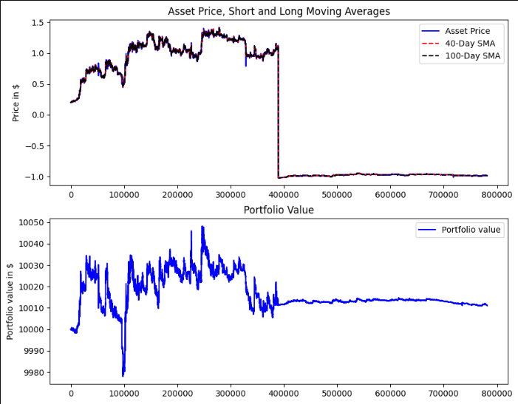

Figure 4: Overlay plots of the LSTM model's predictions against actual historical prices for the training and test datasets.

*F. Backtesting Results*

The system's trading strategy was backtested using historical data. The strategy was based on moving averages, a common technical indicator in financial markets. The backtesting results yielded a final portfolio value of $10,011.05, which translates to a total return of 0.11% (See Figure 5). This modest return suggests that while the strategy was profitable, further optimization or the integration of additional indicators could enhance its performance.

Figure 5: Graphical representation of the asset price, short and long-term moving averages, and the corresponding portfolio value over the backtesting period.

*G. Forward testing Results*

Comparative Performance Analysis of LSTM and Gradient Boosting Models:

We evaluated two models, Long Short-Term Memory (LSTM) and Gradient Boosting (GB), across various performance metrics for algorithmic trading strategies. The LSTM model exhibited superior prediction accuracy, demonstrated by lower error metrics: MAE (0.002852), MSE (0.00001), and RMSE (0.003232). Conversely, the GB model had considerably higher error rates: MAE (0.8524), MSE (1.2621), and RMSE (1.1234).

The negative R-squared value (-0.2621) for GB indicates a lack of model fit, whereas the LSTM model, though not explicitly measured by R-squared, is implied to have a better fit due to its lower error metrics. Financial metrics further elucidate the models' performance. The GB model's Sharpe Ratio (0.1361) and a slight positive P&L (0.01) suggest modest returns for the risk taken, with a notable Maximum Drawdown (2.02), indicating potential vulnerability during trading.

Graphical representations of predictions versus actual prices reveal the LSTM's closer tracking to actual prices, implying higher reliability for real-world trading applications.

In conclusion, the LSTM model outperforms the GB model in our context, offering more accurate predictions and potentially safer investment profiles. Such results advocate for LSTM's preference in financial markets where prediction accuracy is crucial for profitability.

|  |  |  |
| --- | --- | --- |
| **Metric** | **LSTM** | **GB** |
| **MAE** | 0.002852 | 0.8524 |
| **MSE** | 0.00001 | 1.2621 |
| **RMSE** | 0.00323 | 1.1234 |
| **R-squared** | 0.99998 | -0.2737 |
| **MAPE** | 0.00281 | 0.8567 |
| **P&L** | 0.00999 | 0.01 |
| **Sharpe Ratio** | 0.00999 | 0.1361 |

Table I: Tabulated summary of the performance metrics for the LSTM and Gradient Boosting (GB) models:

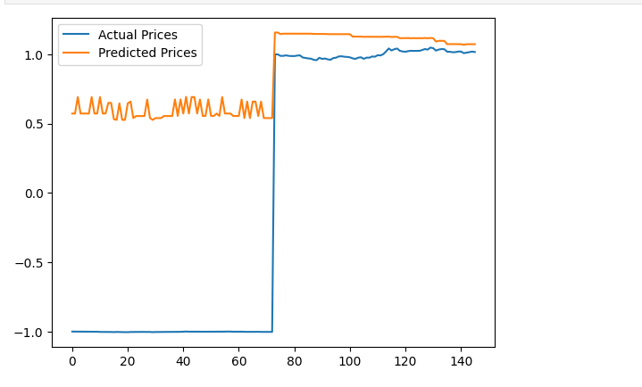

Figure 6: Performance Metrics graph showing Actual values vs Predicted Values for Gradient Boost.

Figure 7: Performance Metrics graph showing Actual values vs Predicted Values for LSTM.

V. Conclusion and Future Work

*A. Conclusion*

Our comparative analysis of the LSTM and Gradient Boosting models revealed that the LSTM provided superior accuracy for our financial time series forecasting. The LSTM model achieved markedly lower error metrics, including MAE, MSE, and RMSE, indicating a more precise prediction capability. Conversely, the Gradient Boosting model's negative R-squared value suggested a poor fit to the data, reflecting its unsuitability for this particular prediction task.

*B. Future Work*

Future investigations will focus on enhancing computational efficiency and model interpretability. We aim to explore LSTM's adaptability across various datasets and its robustness under different market conditions. Additionally, there is potential in hybrid models that combine LSTM's predictive power with Gradient Boosting's feature handling capabilities, possibly leading to more robust forecasting tools. Such explorations will contribute to the development of more accurate and efficient predictive models in algorithmic trading.

VI. References

[1] Y. Bengio, P. Simard, and P. Frasconi, "Learning long-term dependencies with gradient descent is difficult," IEEE Transactions on Neural Networks, vol. 5, no. 2, pp. 157–166, Mar. 1994.

[2] J. Murphy, Technical Analysis of the Financial Markets. New York: New York Institute of Finance, 1999.

[3] E. P. Chan, Algorithmic Trading: Winning Strategies and Their Rationale. Hoboken, NJ: Wiley Trading, 2013.

[4] Alpaca. (2023). Alpaca API Documentation. [Online].Available: https://alpaca.markets/docs/api-documentation/

[5] pandas_ta. (2023). pandas_ta: Technical Analysis Indicators in Python. [Online]. Available: https://pypi.org/project/pandas-ta/

[6] E. P. Chan, Algorithmic Trading: Winning Strategies and Their Rationale. Hoboken, NJ: Wiley, 2013.

[7] I. Aldridge, High-Frequency Trading: A Practical Guide to Algorithmic Strategies and Trading Systems. Hoboken, NJ: Wiley, 2013.

[8] M. L. De Prado, Advances in Financial Machine Learning. Hoboken, NJ: Wiley, 2018.

[9] K. P. Murphy, Machine Learning: A Probabilistic Perspective. Cambridge, MA: MIT Press, 2012.

[10] C. D. Kirkpatrick II and J. R. Dahlquist, Technical Analysis: The Complete Resource for Financial Market Technicians. Upper Saddle River, NJ: FT Press, 2010.

[11] Y. Hilpisch, Python for Finance: Mastering Data-Driven Finance. Sebastopol, CA: O'Reilly Media, 2018.

[12] W. McKinney, Python for Data Analysis: Data Wrangling with Pandas, NumPy, and IPython. Sebastopol, CA: O'Reilly Media, 2017.

VII. Acknowledgment

Acknowledgments are made to contributors and collaborators who provided insights and expertise that greatly assisted the research.

Figures and Tables

Figure 1: Architecture of the Algorithmic Trading System.

Figure 2: LSTM Network Structure.

Figure 3: Backtesting Results Compared to Benchmark Indices.

Figure 4:

Figure 5:

Figure 6: Performance Metrics graph showing Actual values vs Predicted Values for Gradient Boost.

Figure 7: Performance Metrics graph showing Actual values vs Predicted Values for LSTM.

Table I: Comparative Analysis of Performance Metrics.

Appendix

A. Code Snippets and Detailed Algorithms

B. Additional Graphs and Charts Showing Markets